Tab 1
SJR PUBLIC SCHOOL
Rajajinagar Bengaluru

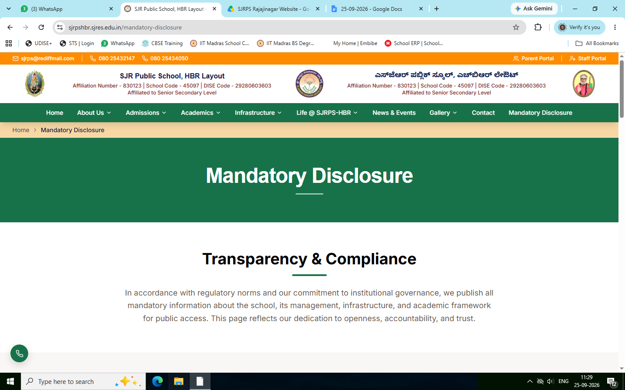

- Retain
The transparency and compliance

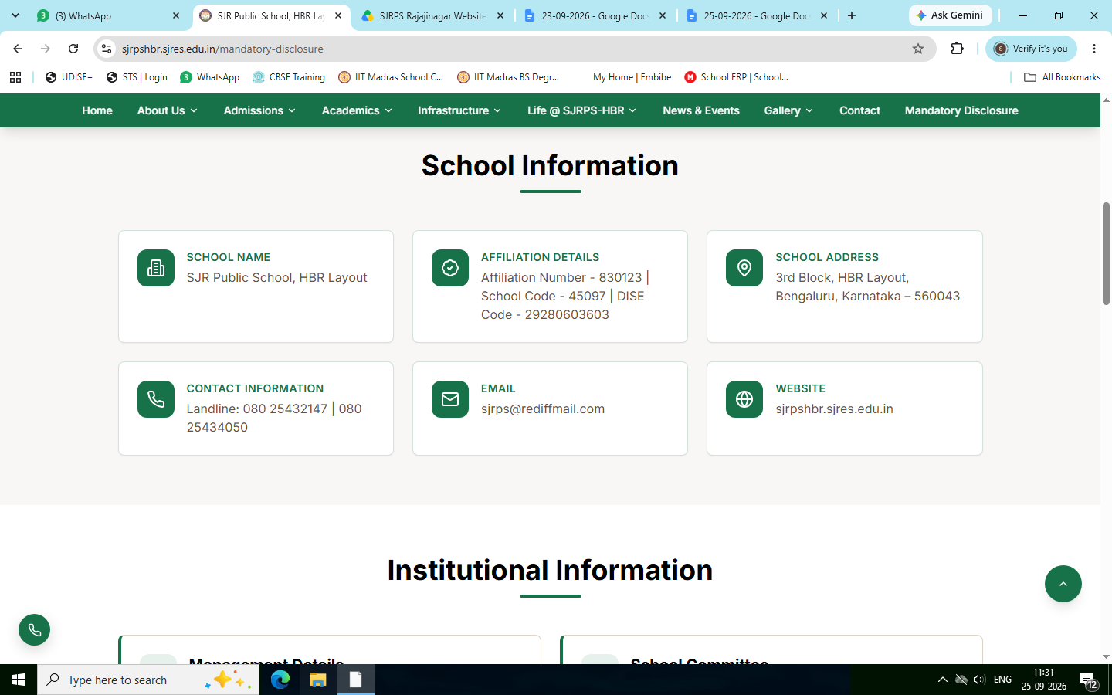
Changes to be done

School Information

School Name - SJR Public School , Rajajinagar

Affiliation details- Affiliation number 831136
School code 46766
DISE code : 29280234402

School address - #1050/A, 4th “M” block , Dr.Rajkumar Road , Rajajinagar,
Bengaluru-560010

Contact information - Landline : 080 -23388765, 080-23102070

Email ID: principalsjrphs@gmail.com

Website : ( will be updated later)

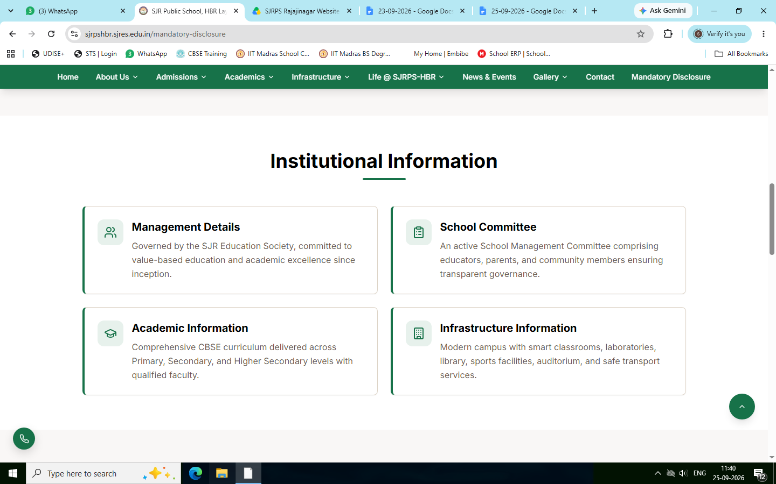

- Retain

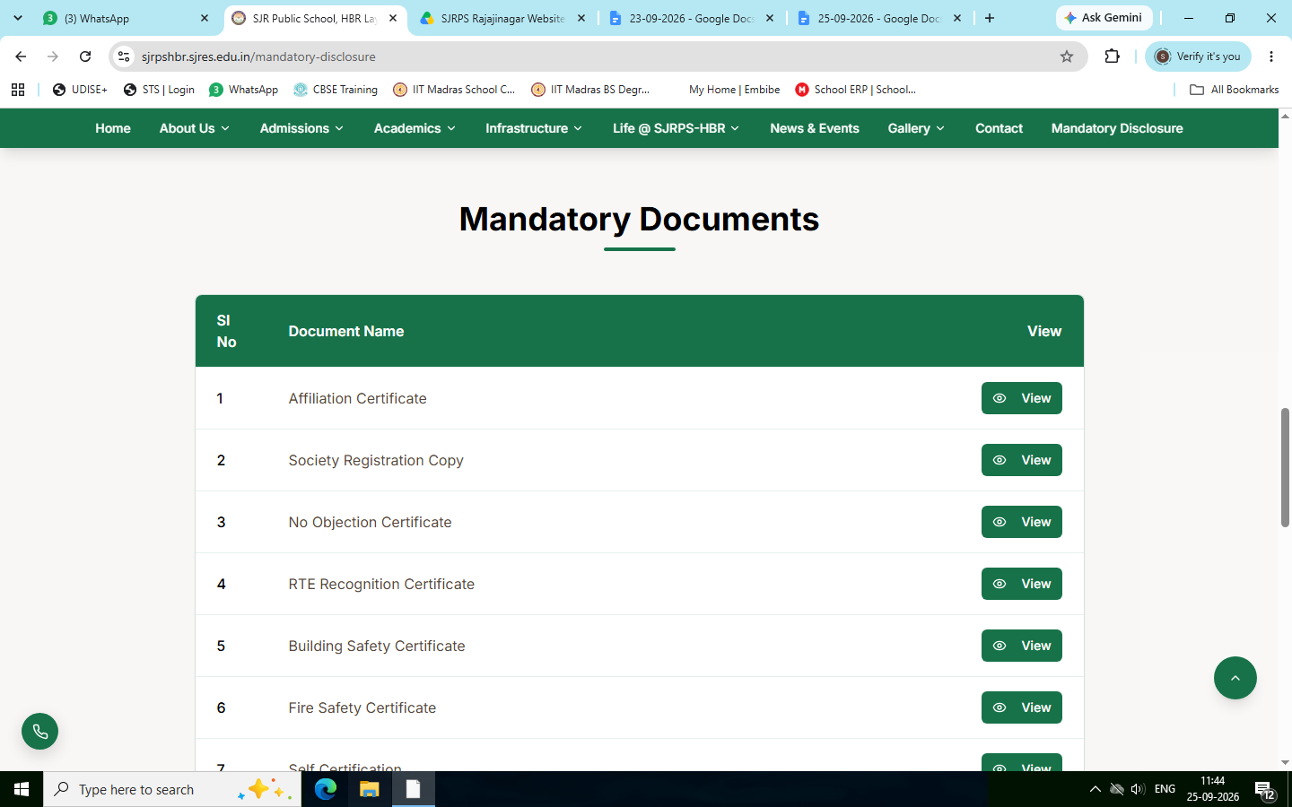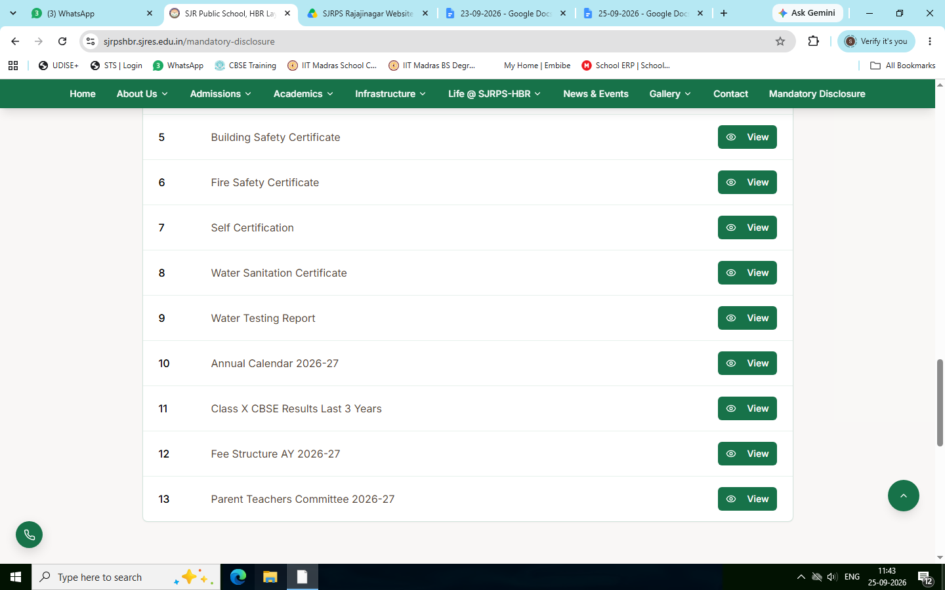

Retain the menu and upload PDF Format (Mandatory Disclosure folder)
- Affiliation certificate
- Society Registration copy
- No Objection Certificate
- Building Safety Certificate
- Fire Safety Certificate
- Self Certificate
- Water Sanitation Certificate
- Water Testing Report
- Annual calendar 2026-27
- Class X CBSE Results last 3 years
- Fee Structure AY 2026-27
- Parent Teachers Committee

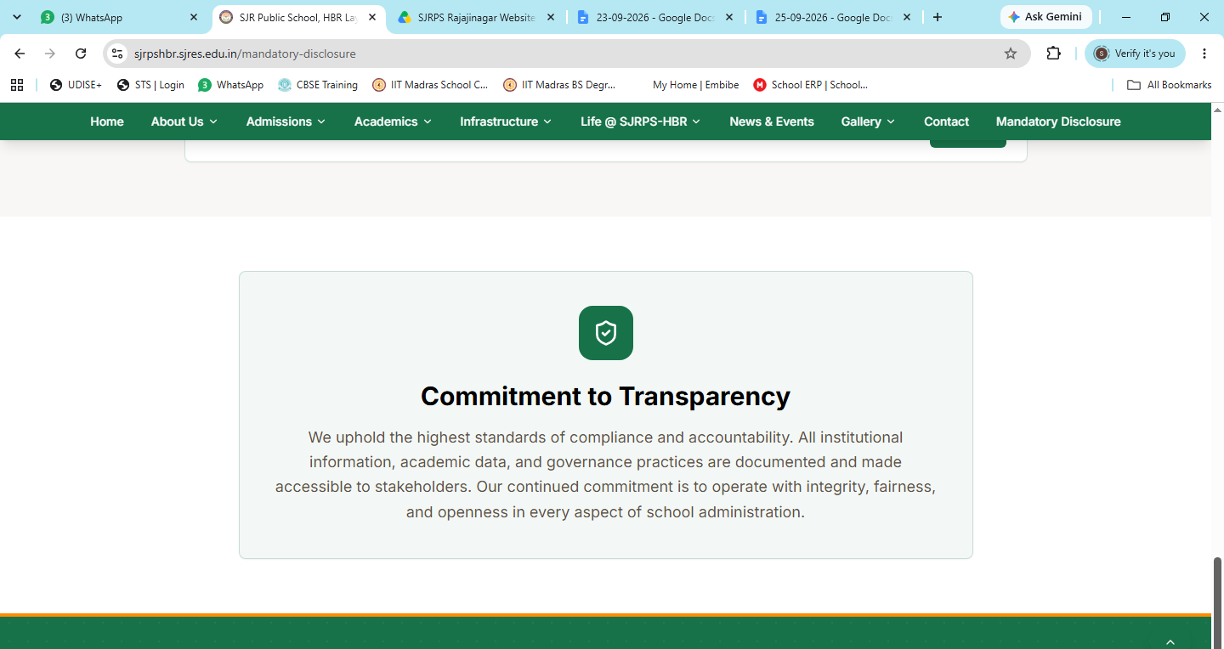

Retain

